ELECTRICAL PAST EXAM BOOKLET

Contents

Syllabus Points 3

Charged Particles 5.1 3

2015 4

2015 4

2022 5

Energy in Circuits – 5.2 6

2015 6

2018 7

2020 8

2021 8

Current and Electron Flow - 5.3 9

2021 9

Resistance 5.4 9

2021 9

2018 SIS 10

2020 13

Series and Parallel Circuits **-** 5.5 16

2018 16

2015 17

2019 19

2020 21

2021 23

2022 25

Electrical Safety and Voltage Dividers - 5.6 27

2015 27

2020 27

2015 28

2018 29

2022 30

# Syllabus Points

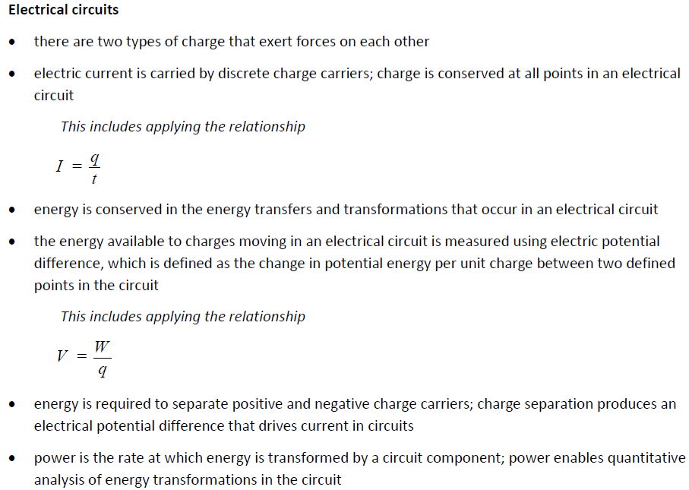

# Graphical user interface, text, application Description automatically generatedCharged Particles 5.1

## 2015

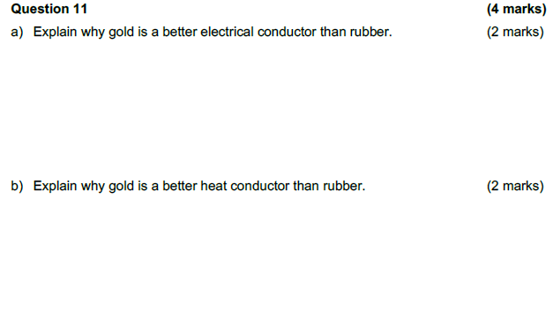

## 2015

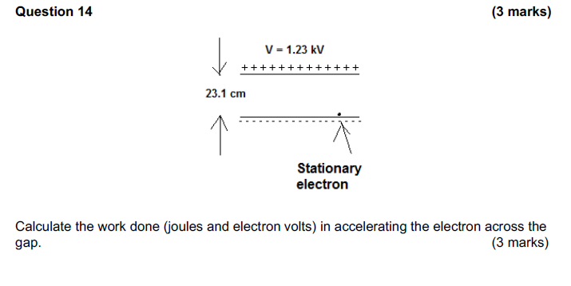

## 2022

# Energy in Circuits – 5.2

## 2015

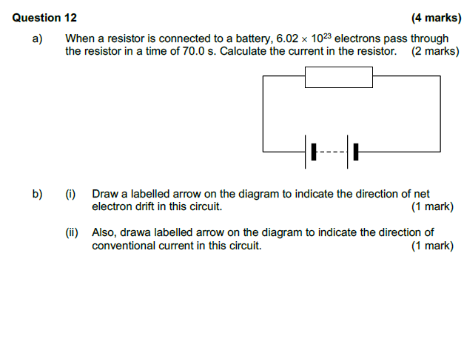

## 2018

## 2020

## 2021

# Current and Electron Flow - 5.3

## 2021

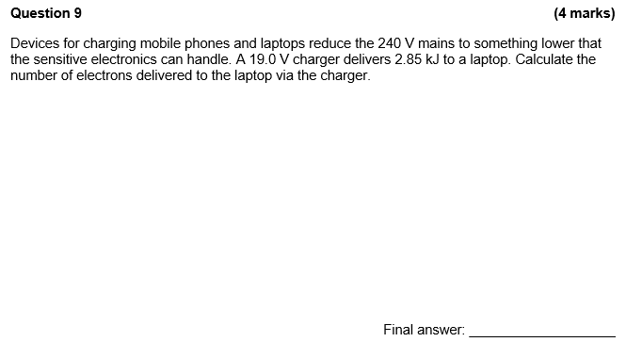

# Resistance 5.4

## 2021

## 2018 SIS

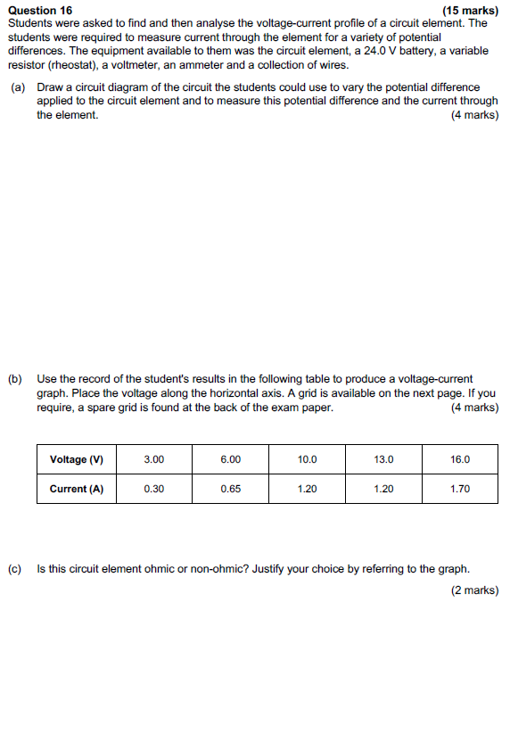

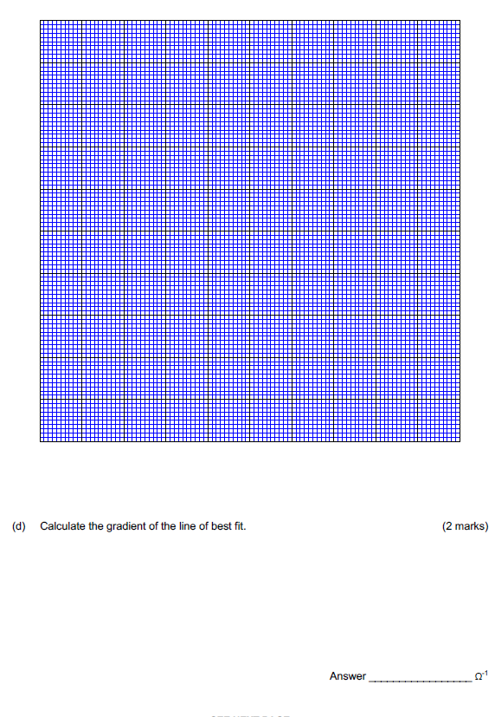

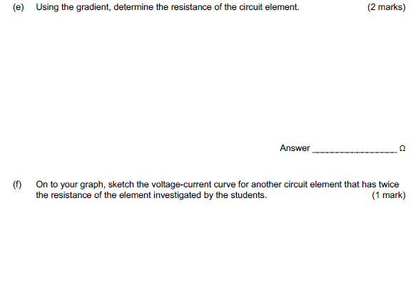

## 2020

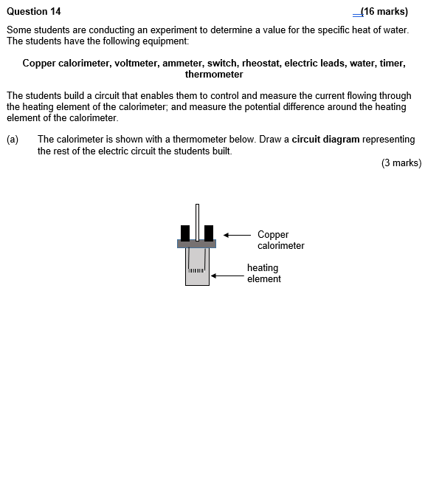

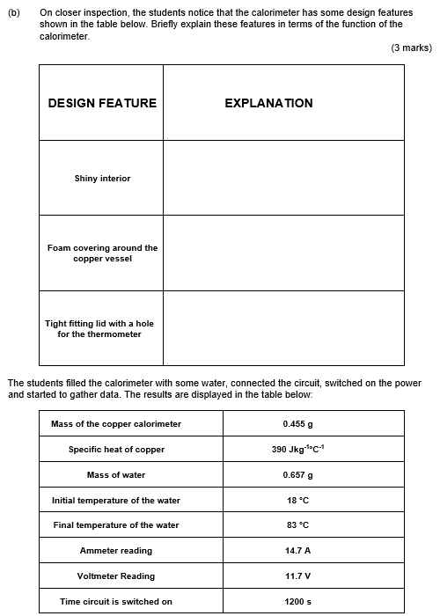

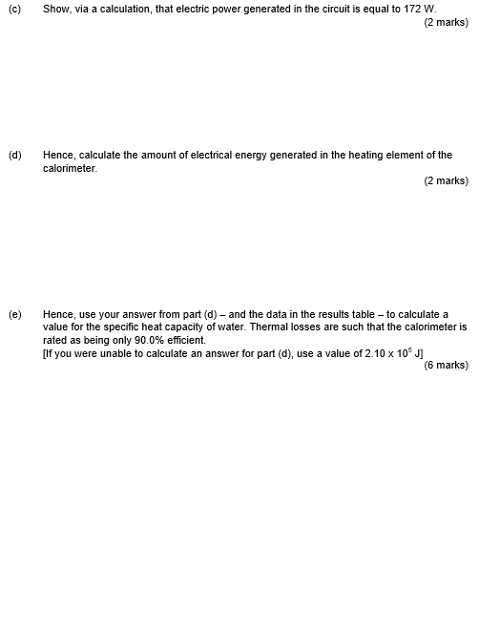

# Series and Parallel Circuits **-** 5.5

## 2018

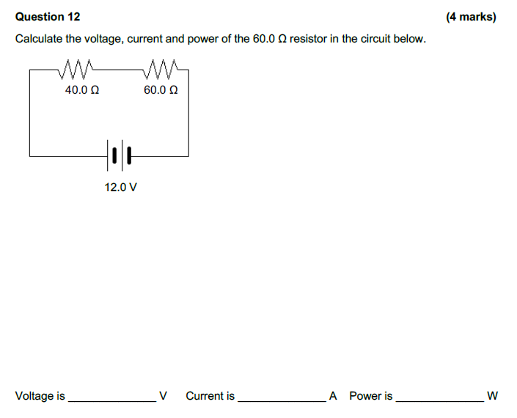

## 2015

## 2019

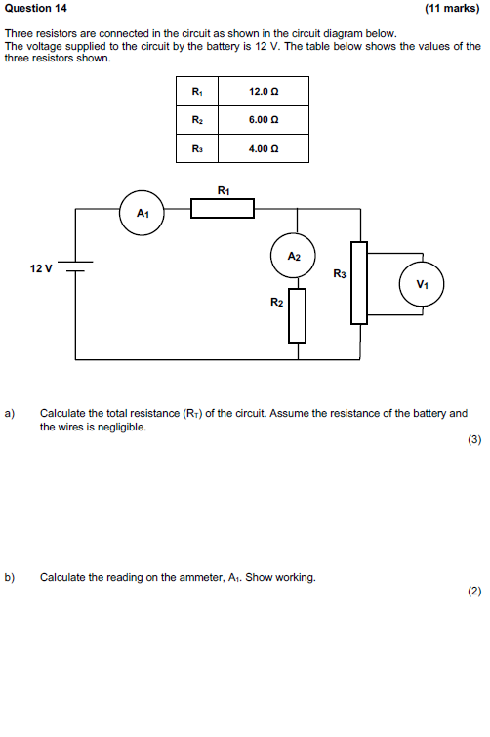

## 2020

## 2021

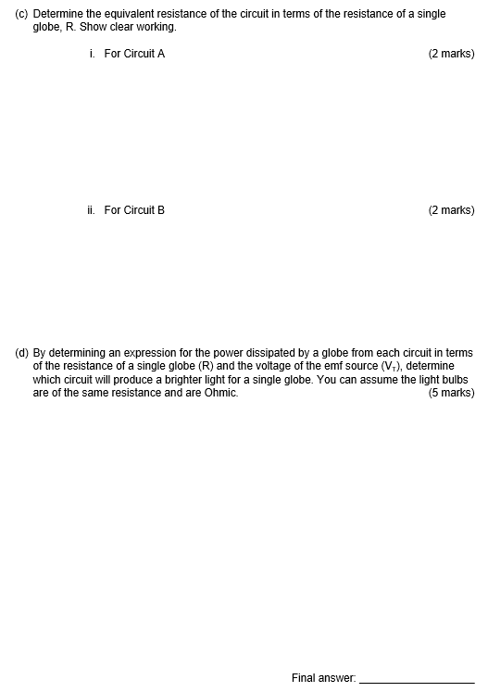

## 2022

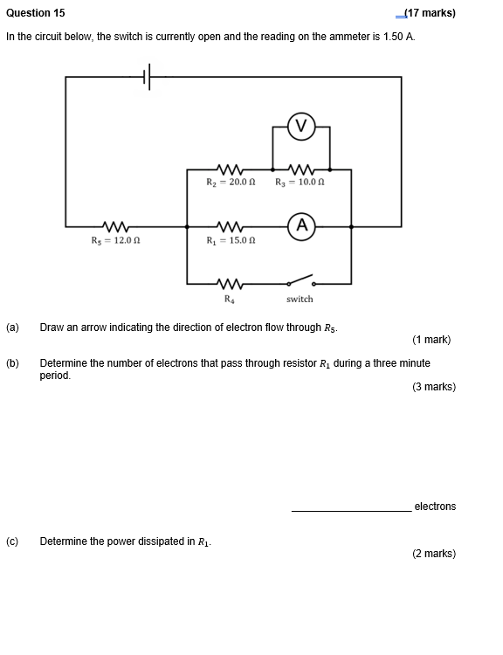

# Electrical Safety and Voltage Dividers - 5.6

## 2015

## 2020

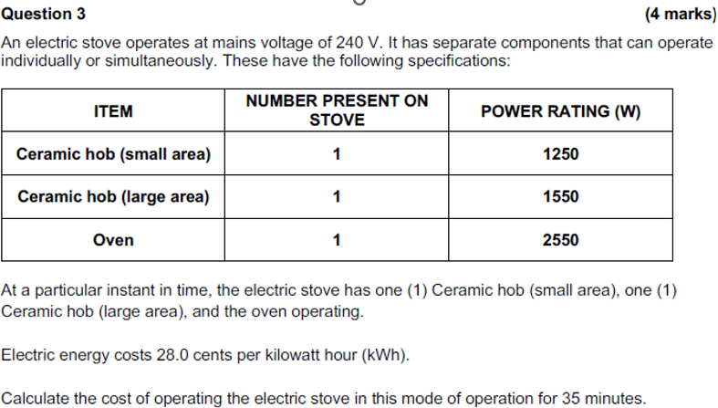

## 2015

## 2018

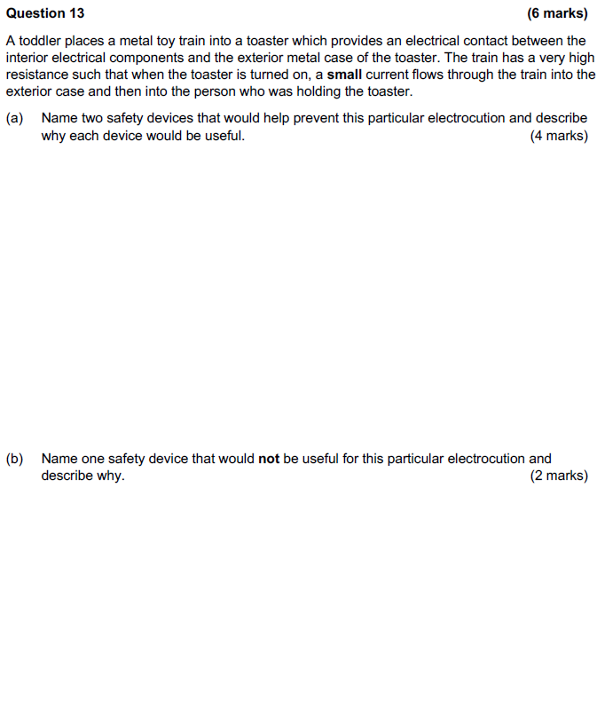

## 2022

